"Ladakh – Journey Beyond the Himalayas”
(4N/5D)

Experience the beauty of Ladakh, a land of majestic mountains, crystal-clear lakes, and ancient monasteries, on this unforgettable 5 Days / 4 Nights journey. Explore the vibrant town of Leh and immerse yourself in its rich culture and timeless heritage. Visit iconic attractions including the Hall of Fame, Magnetic Hill, Gurudwara Patthar Sahib, and the spectacular Confluence of the Indus and Zanskar Rivers. Drive across the legendary Khardung La Pass, one of the world's highest motorable roads, and witness panoramic Himalayan views.

Discover the mesmerizing Pangong Lake, famous for its ever-changing shades of blue and breathtaking landscapes. From peaceful monasteries and dramatic mountain passes to unforgettable road journeys and serene lakes, every moment offers a unique adventure. Perfect for families, couples, adventure seekers, and nature lovers, this itinerary promises an extraordinary Himalayan escape filled with unforgettable memories.

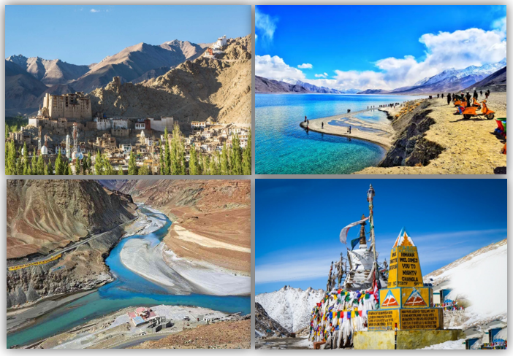

We wish you a happy, safe and unforgettable journey with us
Detailed Itinerary
Day 1: Arrival in Leh
Upon arrival at Kushok Bakula Rimpochee Airport, Leh, meet our representative and transfer to your hotel. Enjoy a scenic drive through the beautiful landscapes of Ladakh before checking in. The rest of the day is kept free for acclimatization to the high altitude. Relax at the hotel, enjoy a welcome tea or coffee, and soak in the peaceful surroundings. Overnight stay in Leh.
Day 2: Indus & Sham Valley Excursion
After breakfast, embark on a full-day excursion through the scenic Indus and Sham Valley. Visit the Hall of Fame Museum (closed on Mondays), the sacred Gurudwara Patthar Sahib, the fascinating Magnetic Hill, and witness the spectacular Confluence of the Indus and Zanskar Rivers. Continue to the magnificent Thiksey Monastery, historic Shey Palace, the famous Rancho School (3 Idiots), and Sindhu Ghat. Return to Leh and visit Leh Palace, Shanti Stupa, and the vibrant Leh Market. Overnight stay in Leh.
Day 3: Leh – Khardung La Pass Excursion
After breakfast, drive to the legendary Khardung La Pass (18,390 ft), one of the world's highest motorable roads. Enjoy breathtaking views of the snow-capped Himalayas, the Indus Valley, and the majestic Saser and Zanskar Ranges. Spend some time capturing memorable photographs before returning to Leh. The evening is free to relax or explore the local market at your own pace. Overnight stay in Leh.
Day 4: Leh – Pangong Lake Excursion
After an early breakfast, set out for the breathtaking Pangong Lake via the spectacular Chang La Pass, one of the highest motorable passes in the world. En route, pass through picturesque villages and stunning mountain landscapes before reaching the famous high-altitude lake, renowned for its crystal-clear waters and ever-changing shades of blue. Spend quality time enjoying the serene beauty of the lake before returning to Leh by evening. Overnight stay in Leh.
Day 5: Departure from Leh
After breakfast, check out from the hotel and transfer to Kushok Bakula Rimpochee Airport for your onward journey. Depart with unforgettable memories of Ladakh's majestic mountains, ancient monasteries, pristine lakes, and thrilling high-altitude adventures. We wish you a safe and pleasant journey home.
Tour ends with unforgettable memories
HOTELS DETAILS:
Destination/Nights | 3* Hotel Name
Leh /04N

Package Cost:

3★ Hotels: Rs. per person (Based on 6 guests – Double Sharing Basis)

Inclusion: -
- Breakfast Included.
- 0 DBL Room on sharing based.
- 04 Nights in Accommodation in hotel.
- Assistance on Arrival.
- All Transfers and S.S tours by AC Vehicle.
Exclusions: -
- 5% GST.
- Flight Tickets are not included.
- Guide.
- Extra meal not included or as per the inclusions given above.
- No extra pickup or drop included for lunch/sightseeing unless otherwise mentioned in the itinerary.

